|  |  |  |  |
| --- | --- | --- | --- |
|  | Stage1 | Stage2 | Stage3 |
| Passband | $$0≤f≤0.025$$ | $$0≤f≤0.025$$ | $$0≤f≤0.025$$ |
| Max Passband Ripple | 0.0084 | 0.0084 | 0.0084 |
| Stopband | $$f≥0.3056$$ | $$f≥0.0833$$ | $$f≥0.0278$$ |
| Stopband deviation | 0.002 | 0.002 | 0.002 |
| Sampling Frequency | 1 | 1/3 | 1/9 |

|  |  |  |
| --- | --- | --- |
| Filter size of each stage | | |
| Stage1 | Stage2 | Stage3 |
| 7 | 12 | 37 |

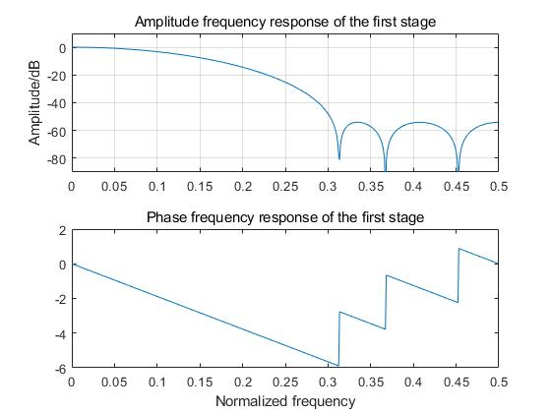

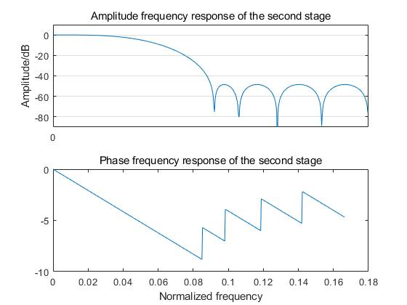

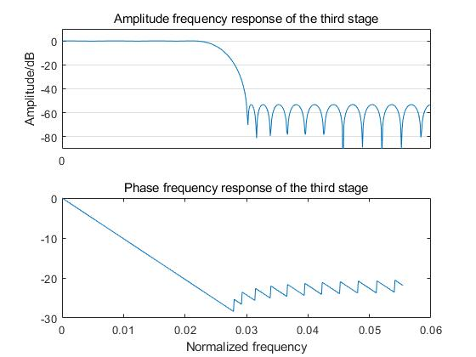

Test results

